# **Topic**

Port of Gold Beach

# **Wireframe**

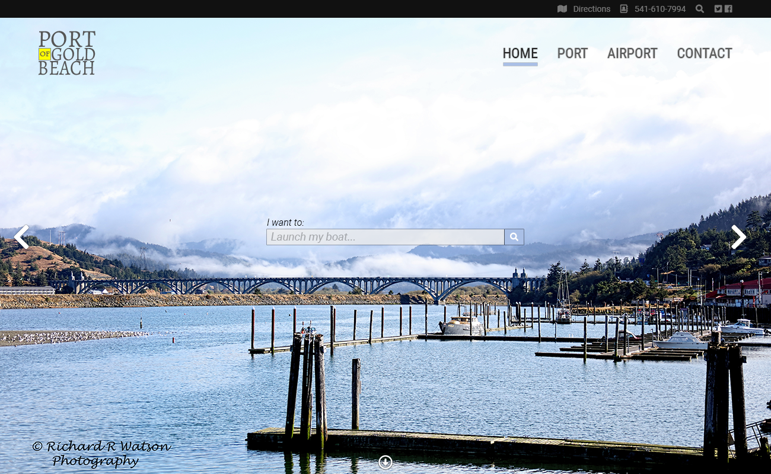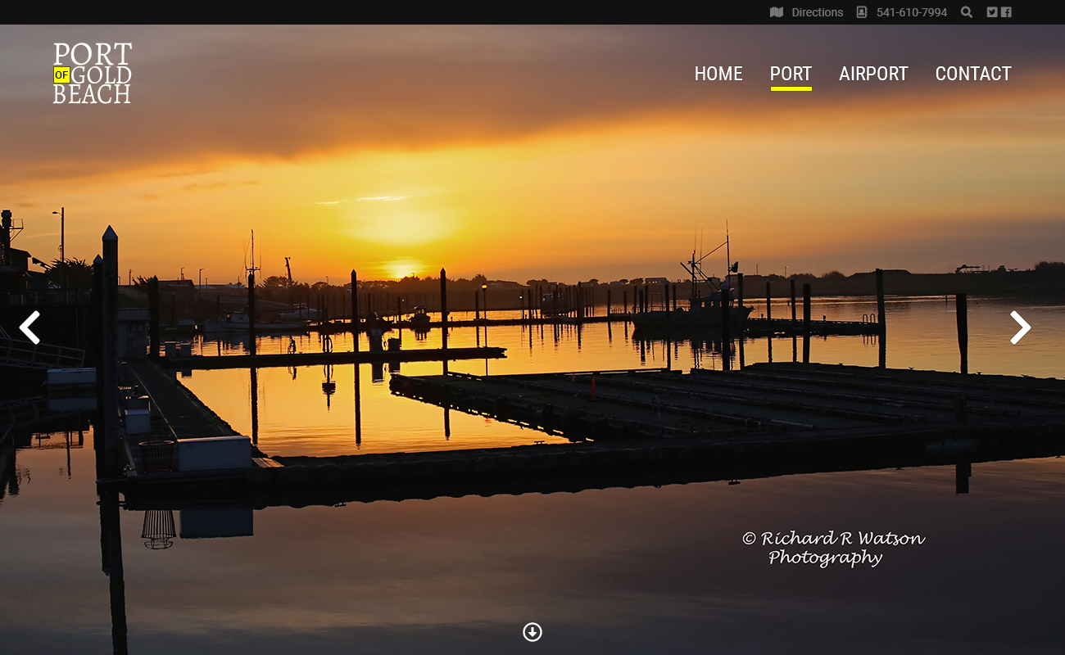

## **Pages**

Home

Port

Airport

Contact